

Topic test 1
Name: __________________________________

Chapter 11: Exponential functions

• Time allowed: 45 minutes
• CAS calculators may be used.
• Part A: 5 multiple-choice questions (5 marks)
• Part B: 13 short answer questions (27 marks)
• Part C: 7 analysis questions (22 marks)
Part A
5 multiple-choice questions
1 mark each: 5 marks
Circle the correct answer.
Use the graphs below to answer questions 1 and 2.
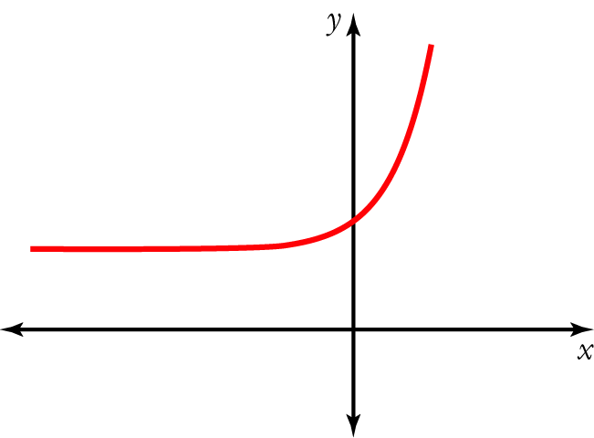
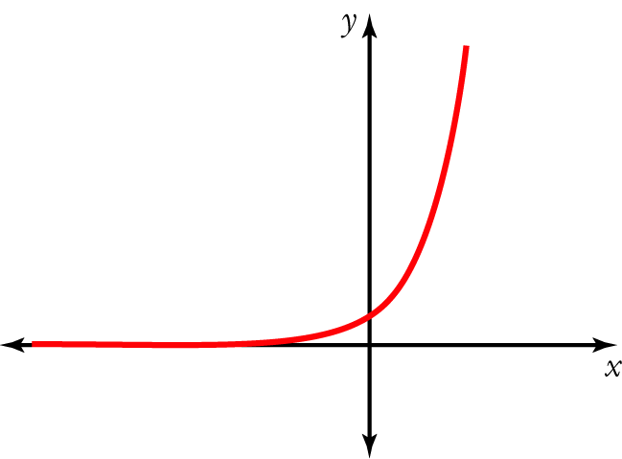
A 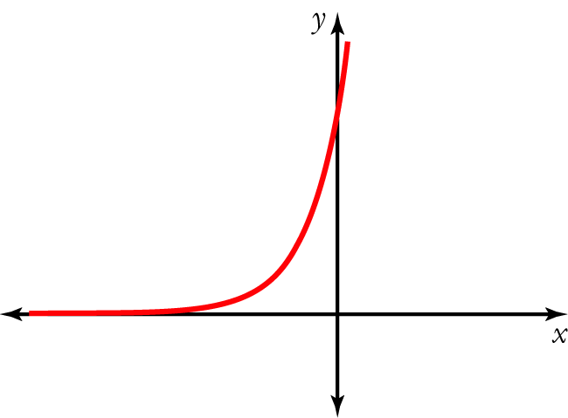 B C
D 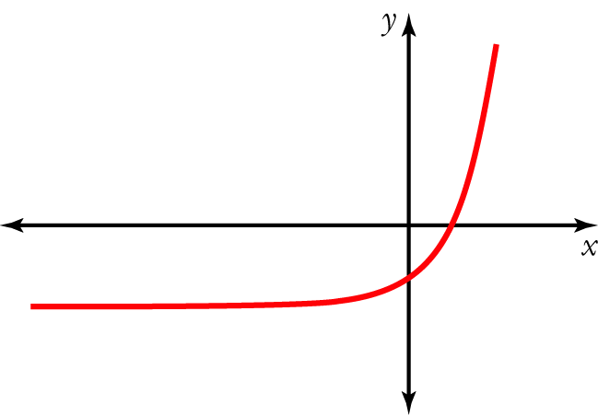 E 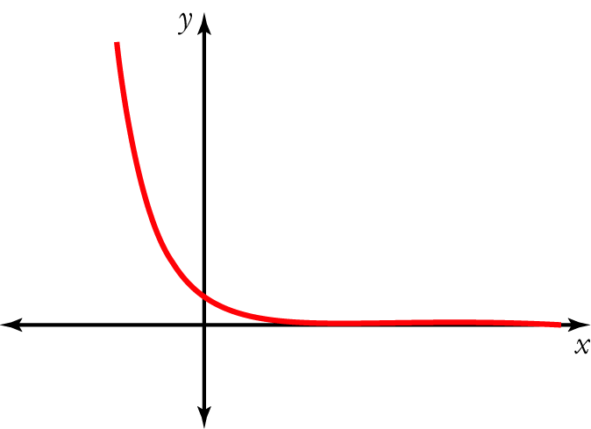
1 Which of the graphs A–E above is most likely to represent y = a^{x} + b, where a > 1 and b > 0?

[1 mark]
2 Which of the graphs A–E above is most likely to represent y = a^{x} + b, where 0 < a < 1 and b = 0?

[1 mark]
3 The solution of 2^{3x+2} − 256 = 0 is:
A x = 8
B x = 6
C x = 2
D x = −2
E x = −6

[1 mark]
4 The table on the right shows some points of an exponential function y = f(x).
x | 1 | 0 | 2 | 3
f(x) | 72 | 60 | 86.4 | 103.68
The initial value a and growth factor b are:
A a = 72, b = 60
B a = 72, b = 1.2
C a = 1.2, b = 60
D a = 1.2, b = 72
E a = 60, b = 1.2

[1 mark]
5 A radioactive sample decays by 5% every year. It has an initial activity of 85.7 mC (millicuries). After 4 years, the activity is about:
A 69.8 mC
B 68.6 mC
C 65.7 mC
D 104.2 mC
E 102.8 mC

[1 mark]
Part B
7 short answer questions
27 marks
Show your working where appropriate.
1 Solve 2x² − 3x − 1 = 0 correct to 3 significant figures.

[2 marks]
2 Simplify and express with positive indices.
a 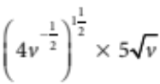

b 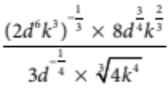

[6 marks]
3 v(t) = 1.9 × (0.7)^{t} + 2. Find the value of:
a v(5)

b v(−3)

[2 marks]
4 Solve the following equations.
a 2^{x+1} = 32

b 4^{3x+1} = 32

c 64^{3x+1} = 32^{5x−4}
[9 marks]
5 The graph of y = 2^{x} is shown. Use the graph to solve 2^{x} = 6
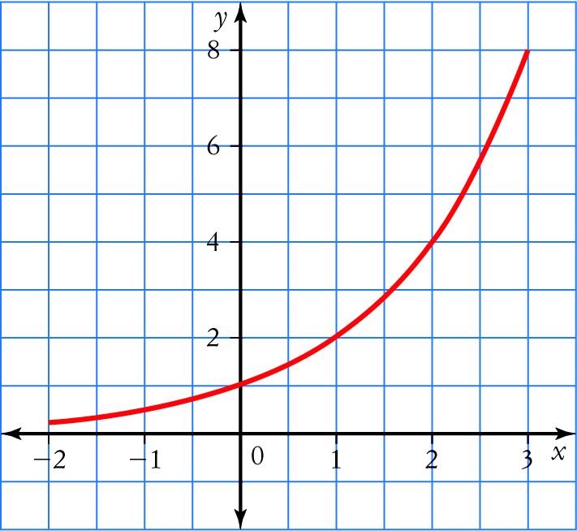
[2 marks]
6 Use a graph drawn with a CAS calculator to solve 16^{x} = 5.

[2 marks]
7 For each of the following exponential functions, calculate the y-intercept and the equation of the horizontal asymptote.
a y = 4 × 2^{(x+3)}

b y = 2 × 0.6^{(x+1)} − 5

[4 marks]

Part C
4 analysis questions
22 marks
Show your working where appropriate.
1 Sketch the graph of each of the following by determining the key features of the graph.
a y = 2^{x} − 5

b y = 3^{x−2} + 2

[6 marks]
2 Sketch the graph of y = 3^{x+3} − 5 by transforming the graph of y = 3^{x}.

[5 marks]
3 The radioactivity of a sample is found to be 150 mCu (millicuries). The radioactive source decays by 2% a year, so the radioactivity decreases at this rate.
a Set up an exponential model of the radioactivity.

b Find the radioactivity of the sample after:
i 5 years ____________________________________________________
ii 10 years ____________________________________________________
iii 100 years ____________________________________________________

c Determine when the radioactivity will have decreased to half its initial value (the half-life).

[7 marks]
4 The population of rabbits in an area increases by an average of 50% every month. How long would it take two rabbits to increase to a population of 3000 rabbits and overrun an area?

[4 marks]
Total marks: 54

Answers
Part A [1 mark each]
1 The graph of y = a^{x} + b will look like the graph of y = a^{x} (where a > 1) that has been translated b units up
because b > 0.
∴ C [1 mark]
2 The graph of y = a^{x} + b will look like the graph of y = a^{x} (where 0 < a < 1) because b = 0.
∴ E [1 mark]
3 Since 256 = 2⁸, rewrite the equation as 2^{3x+2} − 2⁸ = 0 or 2^{3x+2} = 2⁸
Equating the indices, we get 3x + 2 = 8. Solving for x, we obtain x = 2. Alternatively, put each of the options into the equation and see which one gives the correct answer.
∴ C [1 mark]
4 When x = 0, f(x) = 60, so the initial value (a) = 60.
b = 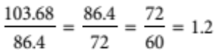
∴ E [1 mark]
5 A = 85.7 × (0.95)^{t} = 85.7 × (0.95)⁴ ≈ 69.8.
∴ A [1 mark]
Part B
1 2x² − 3x − 1 = 0 so a = 2, b = −3 and c = −1 [1 mark]
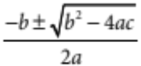 = 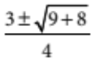 = 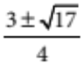 = 1.7807… or − 0.28077…
x ≈ 1.78 or − 0.281 [1 mark]
[2 marks]
2 a 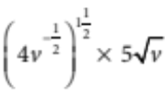 = 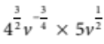 = 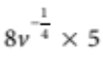 = 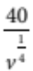 [2 marks]
b = 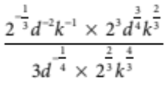
= 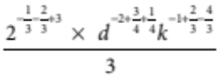
= 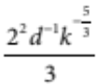 = 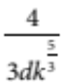 [3 marks]
[6 marks]
3 a v(5) = 1.9 × (0.7)⁵ + 2 ≈ 2.3193 [1 mark]
b v(−3) = 1.9 × (0.7) ⁻³ + 2 ≈ 7.5394 [1 mark]
[2 marks]
4 a 2^{x+1} = 32 ⇒ 2^{x+1} = 2⁵ [1 mark]
⇒ x + 1 = 5 ⇒ x = 4 [2 marks]
b 4^{3x+1} = 32 ⇒ 2^{2(3x+1)} = 2⁵ [1 mark]
⇒ 6x + 2 = 5 ⇒ x = [2 marks]
c 64^{3x+1} = 32^{5x−4} ⇒ 2^{6(3x+1)} = 2^{5(5x−4)} [1 mark]
⇒ 18x + 8 = 25x − 20 ⇒ x = 3 [2 marks]
[9 marks]
5 Locate the point on the graph where y = 6. [1 mark]
Draw a vertical line to intersect the x axis and read the value of x.
x ≈ 2.6
[2 marks]
6 Draw the graph. Use the trace function or locate the zero of 16^{x} − 5 = 0.
x ≈ 0.580 [2 marks]
7 a Let x = 0: y = 4 × 2⁽⁰⁺³⁾ = 32; y-intercept = 32 [1 mark]
Compare with y = a^{x+B} + C : C = 0, so horizontal asymptote is y = 0 [1 mark]
b Let x = 0: y = 2 × 0.6⁽⁰⁺¹⁾ − 5 = −3.8; y-intercept = −3.8 [1 mark]
Compare with y = a^{x+B} + C: C = −5, so the horizontal asymptote is y = –5 [1 mark]
[4 marks]
Part B
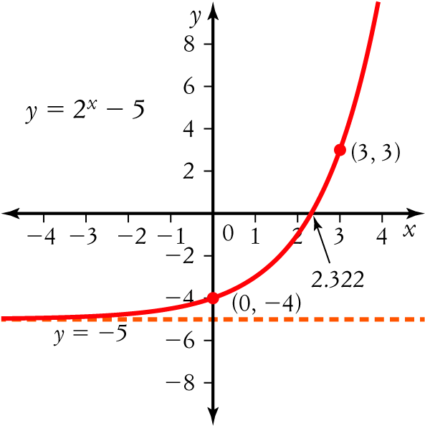
1 a

[3 marks]
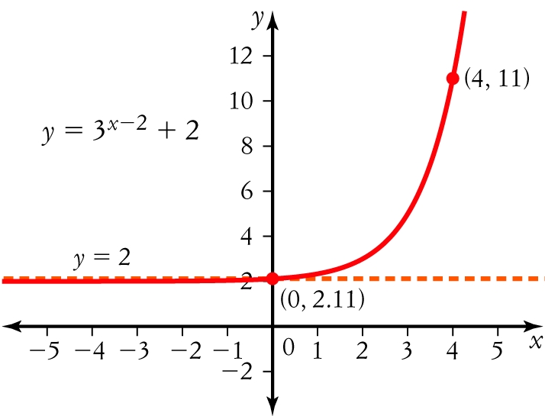
b

[3 marks]
[6 marks]
2 Compare y = 3^{x+3} − 5 with y = a^{x+B} − C. B = 3 and C = −5.
Plot the graph of y = 3x. Slide the graph 3 units to the left and then slide the graph 5 units down. [2 marks]
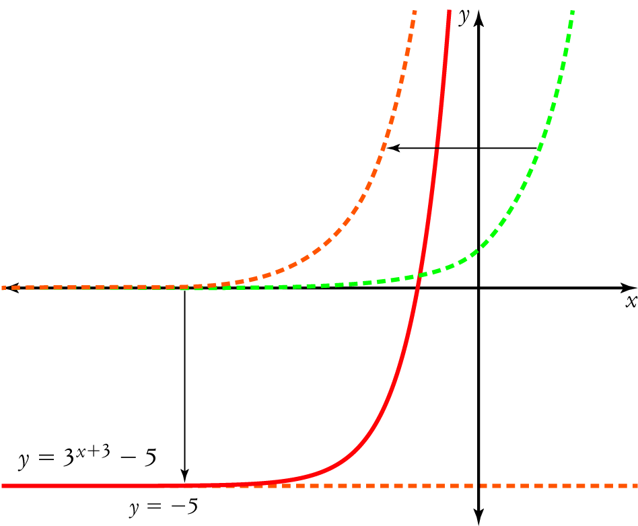
[3 marks]
[5 marks]
3 a Growth factor = (100 − 2)% = 0.98; initial value = 150 [1 mark]
R = 150 × 0.98^{y} [1 mark]
b i R = 150 × 0.98⁵ ≈ 135.5881 mCu [1 mark]
ii R = 150 × 0.98¹⁰ ≈ 122.5609 mCu [1 mark]
iii R = 150 × 0.98¹⁰⁰ ≈ 19.8929 mCu [1 mark]
c At half-life, R = 75 mCu
75 = 150 × 0.98^{y}
0.98^{y} = 0.5 [1 mark]
Use trial and error to solve for y, or use the solve() function on your CAS calculator.
y ≈ 34.3 years [1 mark]
[7 marks]
4 Growth factor = (100 + 50)% = 1.5; initial value = 2 [1 mark]
Let m = number of months
Let P = population of rabbits
P = 2 × 1.5^{m} = 3000 [1 mark]
1500 = 1.5^{m} [1 mark]
Use trial and error to solve for m, or use the solve() function on your CAS calculator.
m ≈ 18.04 months [1 mark]
[4 marks]
ic test 1

